**SQL Homework – 05** Fani Shundovska

1. --We need to return list of: ID of Order, ID of Customer and ID of Employee from orders table, and ID of Product and also Quantity from order details table, only where there is match for the order.*--*

*-- We need to return list of: ID of Order, ID of Customer and*

ID **of** Employee **from** orders **table**, **and** ID **of** Product **AND**

also Quantity **from** **order** details **table**, **only** **where** there **is** **match** **for** the **ORDER**.*--*

**SELECT** o.OrderID **AS** OrderID, o.CustomerID, o.EmployeeID, od.ProductID, od.Quantity

**FROM** orders o **JOIN** `order details` od

**ON** o.OrderID = od.OrderID;

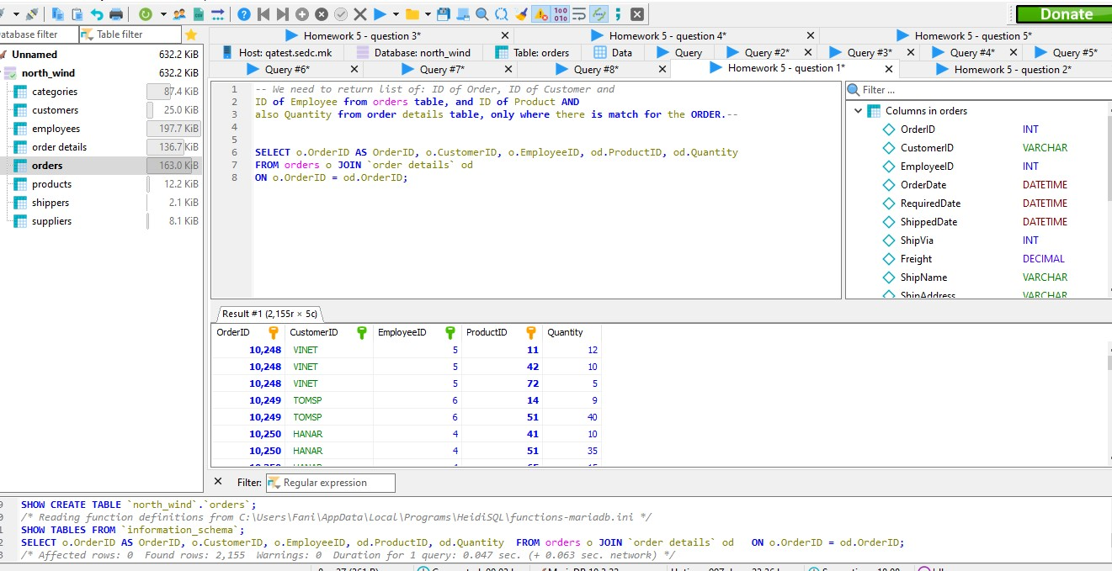

2. -- We need to select all Companies from customer table and return list of all

orders they might have, sorted by Name of Company. --

**SELECT** c.CompanyName, o.OrderID, o.OrderDate

**FROM** customers c **LEFT** **JOIN** orders o

**ON** c.CustomerID = o.CustomerID

**ORDER** **BY** c.CompanyName;

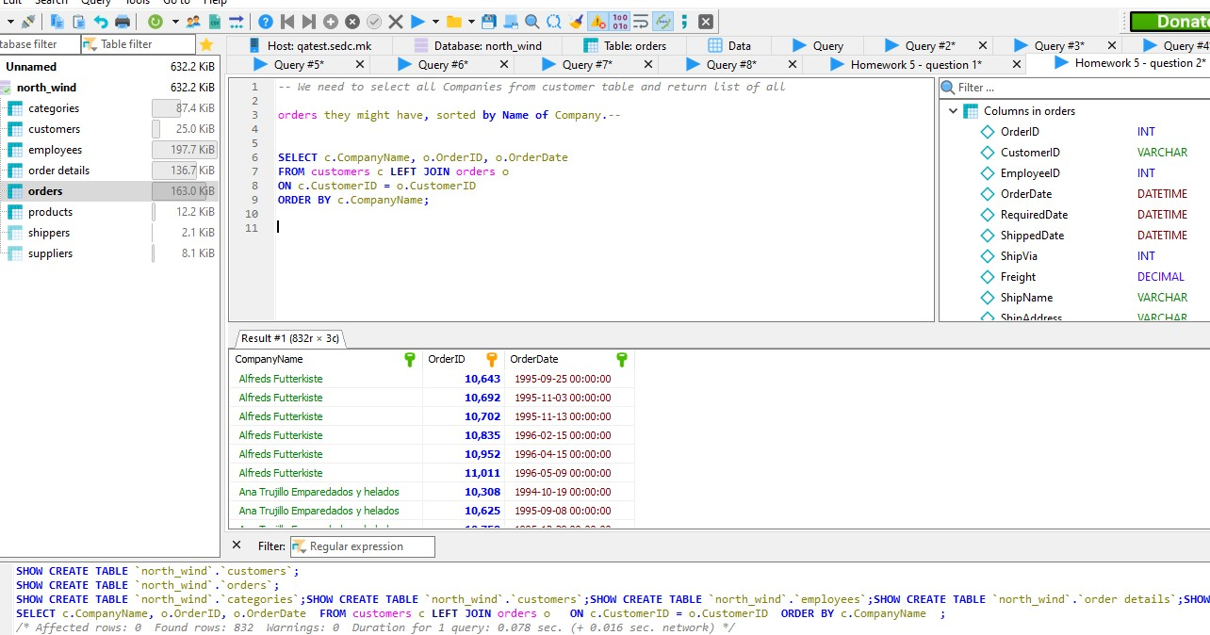

3. We need to select the ID of Order, Employee Last Name, Employee First

Name and Date of Order, for all orders which match the ID of Employee. –

**SELECT** o.OrderID, e.EmployeeID, o.EmployeeID, e.LastName, e.FirstName, o.OrderDate

**FROM** orders o **JOIN** employees e

**ON** o.EmployeeID = e.EmployeeID;

**SELECT** *

**FROM** orders o **JOIN** employees e

**ON** o.EmployeeID = e.EmployeeID;

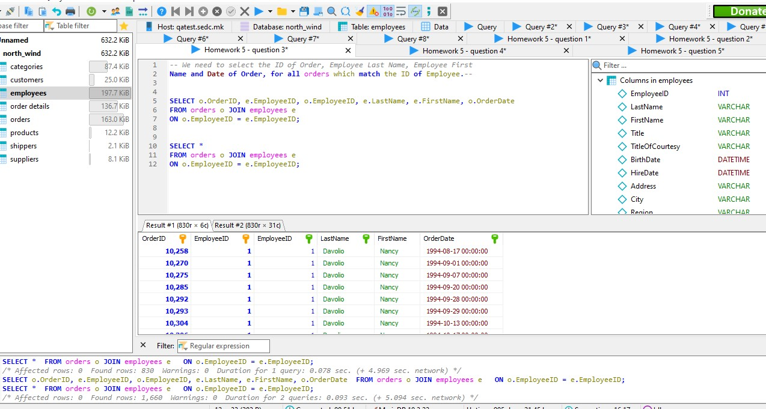

4. --We need to count how much each shipper company made shipments to the city Graz. --

**SELECT** c.CompanyName, o.ShipName, o.ShipCity, od.Quantity, **COUNT**(od.quantity)

**FROM** orders o **JOIN** customers c

**ON** o.CustomerID = c.CustomerID

**JOIN** `order details` od

**ON** o.OrderID = od.OrderID

**WHERE** city = 'Graz'

**GROUP** **BY** od.Quantity;

**SELECT** *, **COUNT**(*) **AS** shipment_count

**FROM** orders o **JOIN** customers c

**ON** o.CustomerID = c.CustomerID

**JOIN** `order details` od

**ON** o.OrderID = od.OrderID

**WHERE** city = 'Graz'

**GROUP** **BY** od.Quantity;

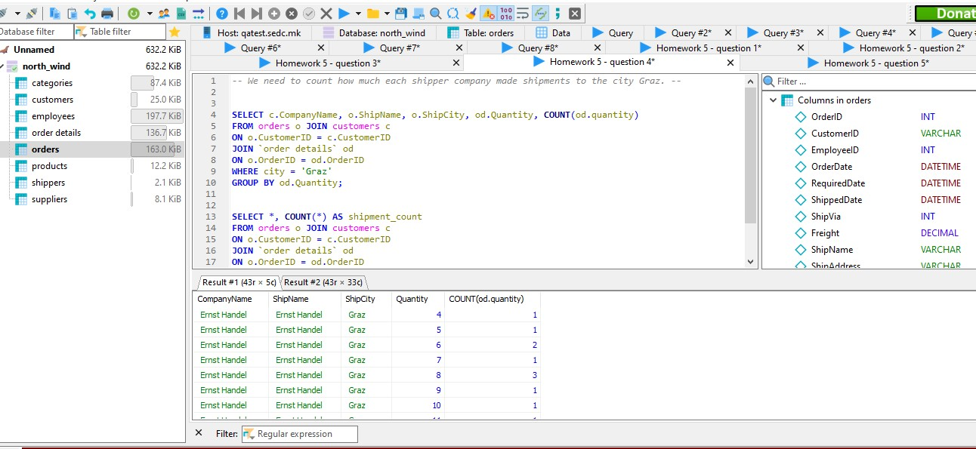

5. -- We need to list all the customers that are and have orders from Brazil but not from Rio de Janeiro --

**SELECT** *

**FROM** customers c **JOIN** orders o

**ON** c.CustomerID = o.CustomerID

**WHERE** c.Country = 'Brazil' **AND** c.City <> 'Rio de Janeiro'

**ORDER** **BY** c.City;

